**PCB Design**

During PCB, the factors, which should be taken into consideration can be specified as follows:

* Radiated Electromagnetic Interference
* Conducted EMI
* Power Supply Stability
* Efficiency
* Operation Longevity

Among these factors, EMI, electromagnetic disturbance, was considered as the most important factor that could cause PCB malfunction. Since one of the main reasons of Radiated Electromagnetic Interference is switching devices, special attention should be paid to the placement of the switching elements in the Buck Converter. Moreover, the loops of the switching elements should be as small as possible. For all these reasons, the input capacitor and inductor of the buck converter were the first circuit elements to be placed in the PCB design. A design was developed in which the inductor and capacitor loops were minimized as much as possible.

Circuit design is made on a double layer PCB. During the PCB design, 2 different options were considered while capacitor and inductor placements were performed. In the first of these options, all circuit elements are placed on the upper layer, while in the second option, the capacitor and inductor are placed on the lower layer. Since the first option causes the inductor and capacitor loops to lengthen, and therefore increasing the EMI effect on the PCB, the development has been continued with the second option. In addition to this, the circuit size has been reduced and the PCB price has been reduced with the two-sided PCB design, which can be observed in the Figure ….

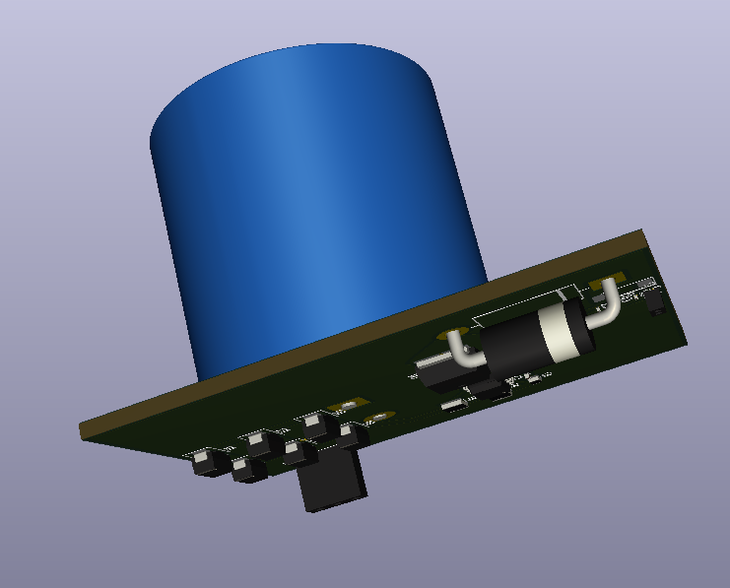

Figure 1: Two-sided PCB design view

Placement of the other circuit elements adjusted according to inductor and output capacitor of the rectifier. As can be observed in Figure …, while MOSFET is placed near one of the inductor connections, output capacitors of the Buck Converter are placed near to its other connection. In addition, it has been deemed appropriate to keep the diode on the upper surface in order to leave the switching loop even smaller. Moreover, the controller IC is placed close to the MOSFET.

While the rectifier output capacitor is placed close to the rectifier outputs, it has been approximated to the converter circuit by taking physical limitations into account. The layout view of the PCB design can be observed from Figure …. While red traces show connections on the upper layer, green traces show connections on the bottom layer of the PCB. In this layout, the circuit elements placed on the bottom surface are shown in pink color.

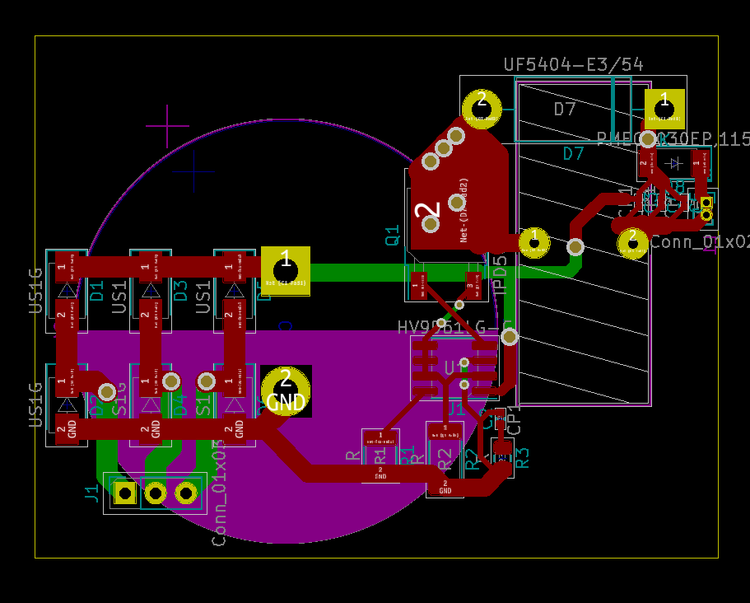

Figure : PCB design layout view without copper pouring

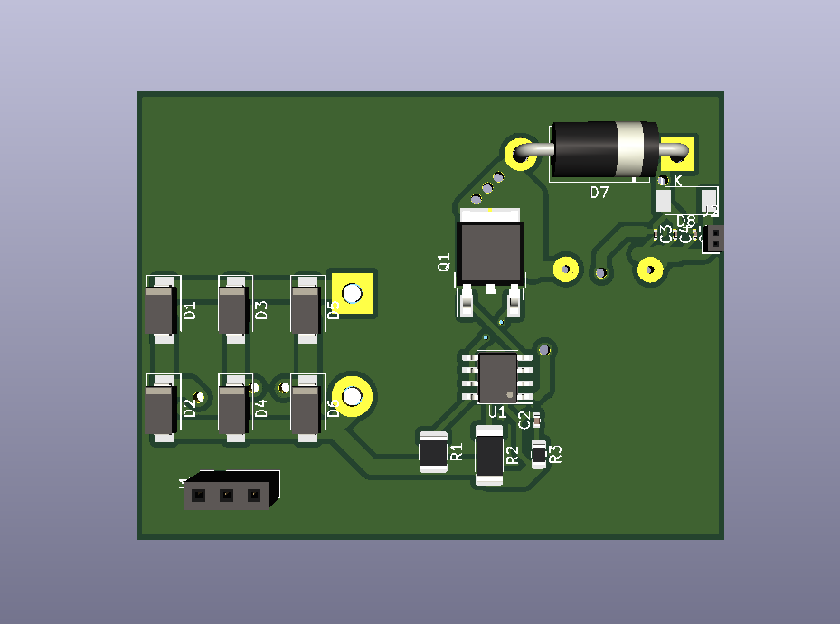

Figure : 3D top layer view of the PCB design

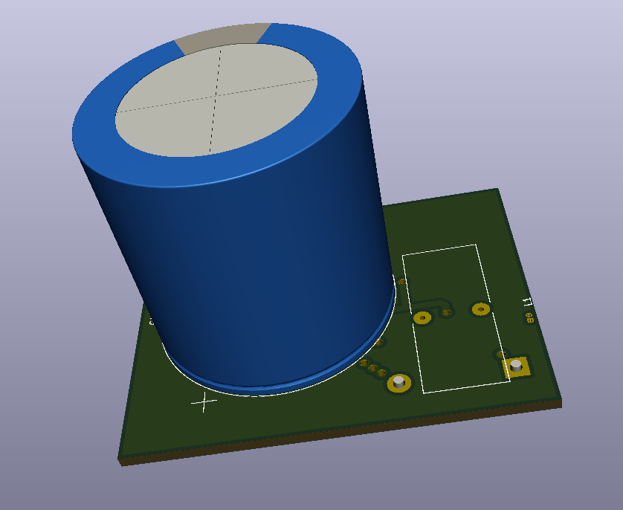

Figure : 3D bottom layer view of the PCB design